***School of Mechanical & Manufacturing Engineering (SMME),***

***National University of Science and Technology (NUST),***

***Sector H-12, Islamabad***

***AUTOCAD: ORTHOGRAPHIC PROJECTION***

**ASSIGNMENT REPORT**

Program :    BE-Aerospace                          Section    :  AE-01

Session  :    Spring 2024                              Semester :  2nd

Course Title:  Engineering Drawing AE-103

Fatima Imran (457281)

**DRAWING 01:**

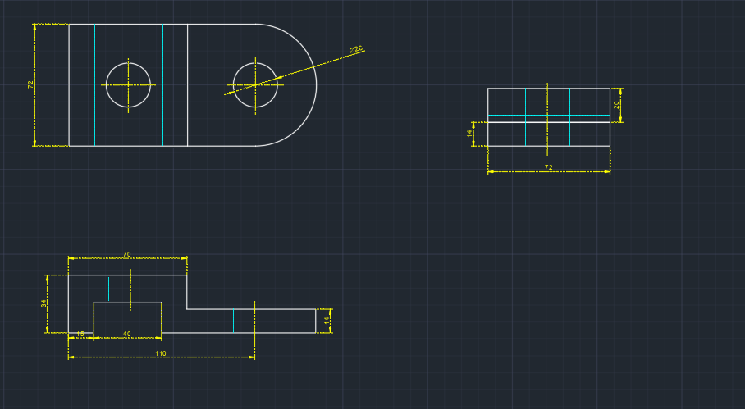

Top left is the top view of piece and at its bottom is front view. While the other is left hand side view.

The general operations that were used in drawing figure were:

* **Offset**: To draw lines that were on both sides at same distance from a centre line.
* **Circle:** The radii and circle mentioned were drawn by this tool.
* **Mirror**: To conserve energy and work efficiently, mirror tool was used to copy the lines along an axis.

The figures were firstly made with continuous line following the hidden lines and centre lines to show the parts not visible and centres of radii or circles respectively.

Then dimension lines were used to mark dimensions along horizontal, vertically and of radii of circles.

**DRAWING 02:**

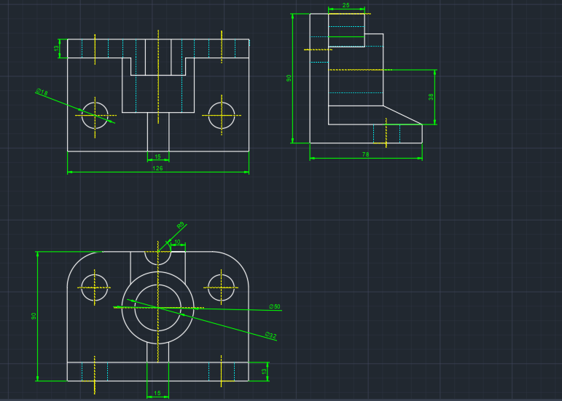

Top left is the top view of piece and at its bottom is front view. While the other is left hand side view.

The general operations that were used in drawing figure were:

* **Offset**: To draw lines that were on both sides at same distance from a centre line.
* **Circle:** The radii and circle mentioned were drawn by this tool.
* **Mirror**: To conserve energy and work efficiently, mirror tool was used to copy the lines along an axis.
* **Fillet:** This feature was utilized to to make edges curved.

The figures were firstly made with continuous line following the hidden lines and centre lines to show the parts not visible and centres of radii or circles respectively.

Then dimension lines were used to mark dimensions along horizontal, vertically and of radii of circles.

**DRAWING 03:**

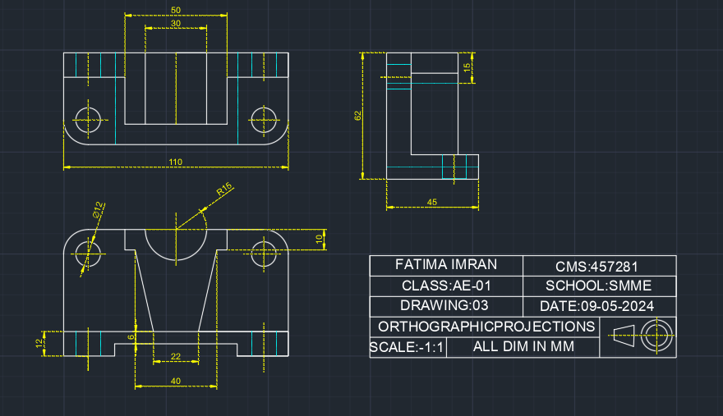

Top left is the top view of piece and at its bottom is front view. While the other is left hand side view.

The general operations that were used in drawing figure were:

* **Offset**: To draw lines that were on both sides at same distance from a centre line.
* **Circle:** The radii and circle mentioned were drawn by this tool.
* **Mirror**: To conserve energy and work efficiently, mirror tool was used to copy the lines along an axis.
* **Fillet:** This feature was utilized to to make edges curved.

The figures were firstly made with continuous line following the hidden lines and centre lines to show the parts not visible and centres of radii or circles respectively.

Then dimension lines were used to mark dimensions along horizontal, vertically and of radii of circles.